# Coreference Annotation

We’ve developed an interface to collect human annotations of sequential coreference links in text, as follows. A document is broken down into overlapping passages (windows) of six or fewer sentences. An annotator is shown one passage at a time, and entity mentions in the last sentence of a passage are highlighted. For each of these *query mentions*, the annotator is tasked with identifying the previous mention of the entity or indicating there is no previous mention in the passage. To facilitate the annotator’s task and reduce noise in the output, likely entity mentions, which we call *candidate mentions*, are automatically detected in each document prior to annotation, and the annotator must select answers from among these mentions:

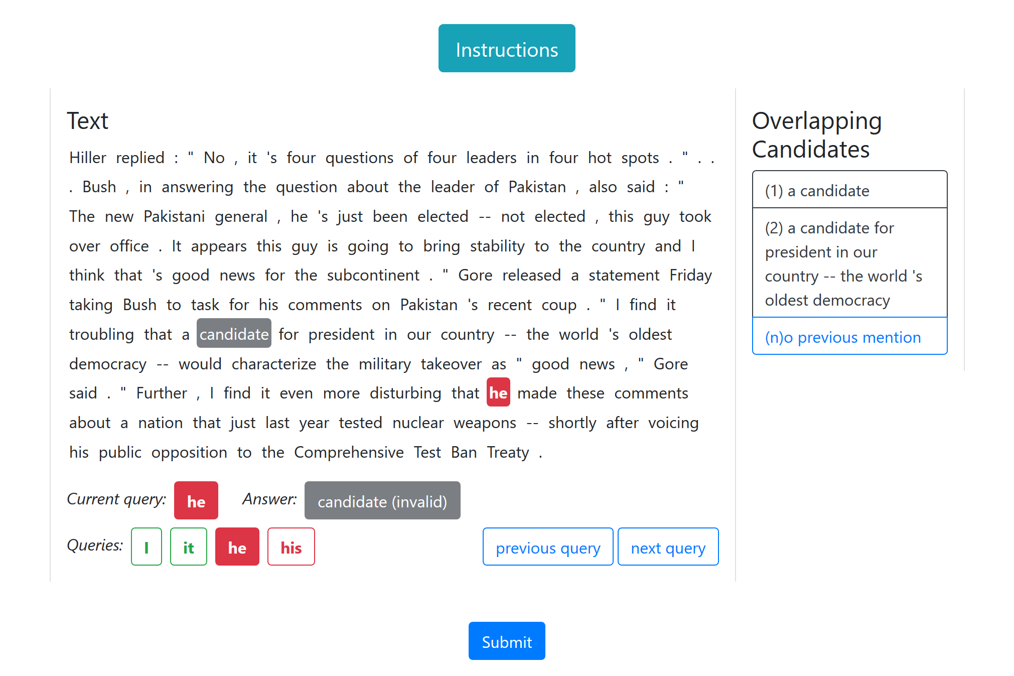

In this screenshot of the interface, there are four query mentions in the last sentence, which the annotator can navigate between using the buttons in the “Queries” list. The third query, “he,” is given a solid red color to indicate that it is highlighted in the passage and the annotator’s selection, the word “candidate,” is not a candidate mention. On the right, two candidate mentions overlapping the selection are presented for the annotator to choose from. After selecting a candidate mention for “he,” the annotator would need to select a valid answer for the fourth query mention before submitting their work.

Initially, five HLTCOE linguists annotated all sentences containing query mentions from the Universal Decompositional Semantics data set, annotating the training set with 2x redundancy (two annotators per passage) and annotating the dev and test sets with 3x redundancy Annotators commented, both in initial impressions and in conclusion of the work, that the interface is both user-friendly and efficient, with the difficulty of the task increasing for long passages, and 75% of all passages being annotated in less than 30 seconds. Agreement between annotators was also high, with both annotators on the training data agreeing 77% of the time and all three annotators on the dev and test data agreeing 65% of the time:

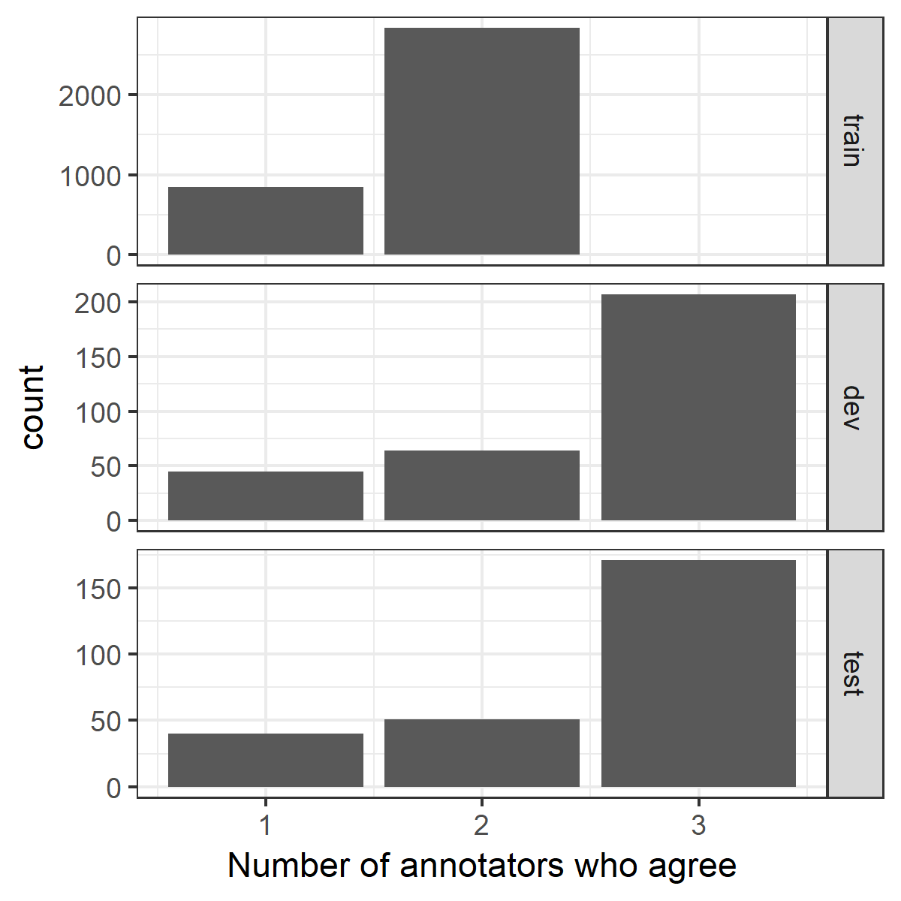

To enable inspection of the annotations by researchers, a web annotation viewer was also developed. This viewer presents a randomly sampled passage from the annotated data, listing the query mentions as in the annotation interface and displaying each annotator’s answer to the currently active query mention with a different color. By clicking “Sample New HIT,” researchers can view a new randomly sampled passage, enabling them to rapidly develop observations and intuitions about the annotated data as a whole:

